Homework 8:Cooling of a Lave Dike

*For this lab please enter your answers into the tables here in this document*

*and then submit along with your notebook.*

This homework set is very much based on this week’s computer lab.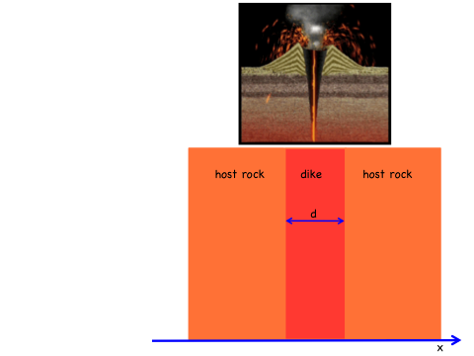 We study the cooling of lava filled dike and derive the temperature distributions *T(x,t)*. The lava has an initial temperature of 1300°C, and surrounding host rock host rock has one of 0°C. We assume the dike has a width of *d*=5 meters and is infinitely long in *y* and *z* directions. For rock and lava, use

a heat capacity of 1.12 Joule/gramm/Kelvin,

a density of 2.65 gramm/cm3,

and a heat conductance of 0.032 J/cm/seconds/Kelvin.

Discretize the dike into N=50 intervals. Then add a layer of host rock of width 2×d on each side, which brings the total number of intervals to 5×N. This determines your initial conditions. Choose Dirichlet boundary conditions, *T=0,* on each side.

***Q:*** *Main question of this problem: What is the temperature in the middle of the dike after (a) 1 hour, (b) one day, (c) one week, (d) one month, and (e) after one year?*

(1) Write a Python code that solves the 1D heat equation in real time using the following scheme:



What unit of length do you use in your code? ______

What unit of time do you use? _____

What is the coefficient k (see lecture 11)? Specify value and units: ______

What is you grid spacing Δx? _____

What is your time step Δt? ____ (should be on the order of minutes)

Work out the coefficient η (see lecture 11)? ______

*Exchange your answers to these questions with at least one other student before you start coding or come to our office hours. Write and run your Python code for simulation parameters you listed above, answer question Q, and enter your results here:*

|  |  |
| --- | --- |
| Cooling time | Temperature at the dike center |
| 1 hour |  |
| 1 day |  |
| 1 week |  |
| 1 month |  |
| 1 year |  |

(2) Increase the spatial resolution to N=100, 150, 200, 250, 300… points in the dike until all answers to Q change by less than 1.5°C when compared line-by-line to your previous calculation with a smaller N. When you change N, please adjust Δt so that η remains constant. Enter your converged results in the table below. Your results should not differ too much from table (1).

One question: If you increase N by a factor 2, by what factor does the number of calculations increase and therefore the run time increase? _______________

I used N= …

|  |  |
| --- | --- |
| Cooling time | Temperature at the dike center |
| 1 hour |  |
| 1 day |  |
| 1 week |  |
| 1 month |  |
| 1 year |  |

(3) Using again N=50, increase the width of the host rock layers from 2×d to 4×d, 6×d, 8×d, … until the results for Q are converged to a precision of 1.5°C. Specify the width that was needed and enter another table here:

I used the following width for the host rocks layers = … ×d

|  |  |
| --- | --- |
| Cooling time | Temperature at the dike center |
| 1 hour |  |
| 1 day |  |
| 1 week |  |
| 1 month |  |
| 1 year |  |

(4) Finally compute how much heat the lava loses as function of time. The thermal energy is proportional to area under the *T(x,t)* curve. Integrate the area inside the dike region and report what fraction is heat is lost for the time spans a)-e) by adding another column to the table in part (3).

|  |  |
| --- | --- |
| Cooling time | Fraction of original thermal energy |
| 1 hour |  |
| 1 day |  |
| 1 week |  |
| 1 month |  |
| 1 year |  |